**Login Page**

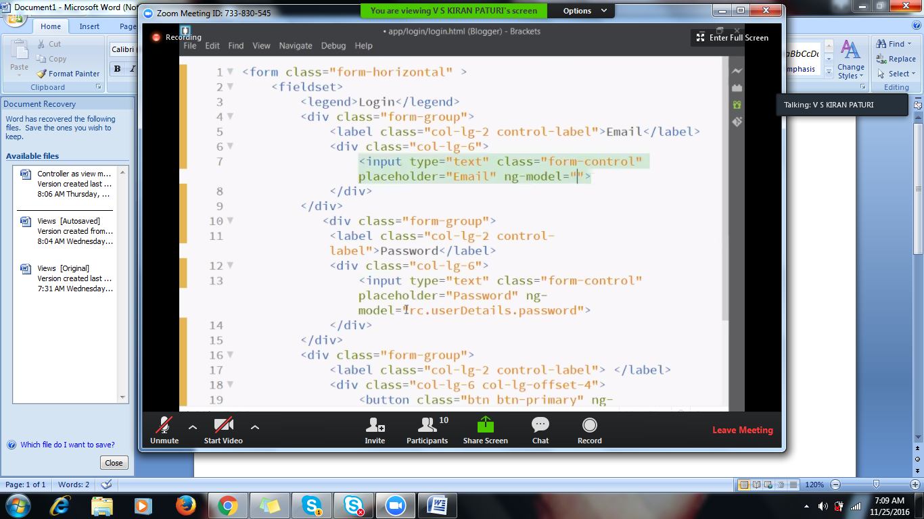

**Login Controller (In** Login.js)

Creating the module

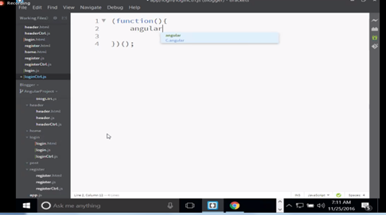

**Step 2: Creating controller**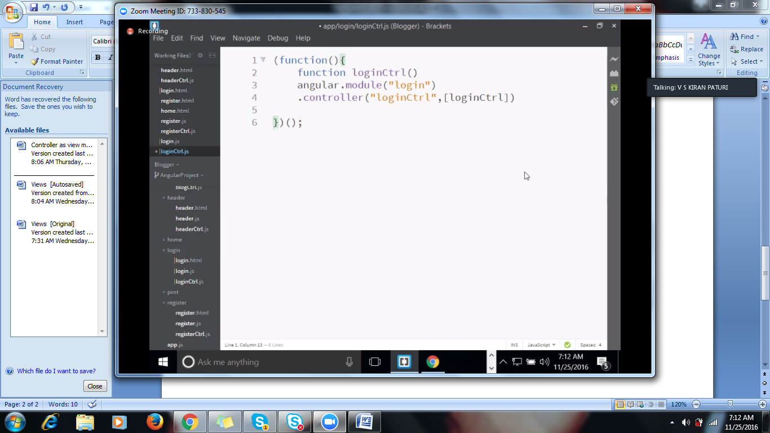

**Step3:**

**Creating variable: Exposing controller as a view to object**

**Case 1:** Var vm=this;

Vm.user-={} //creating an object( will show username and password in this object)

**Case 2:** Else we can write as

this. user={};



**Step 3 : Refer login control** 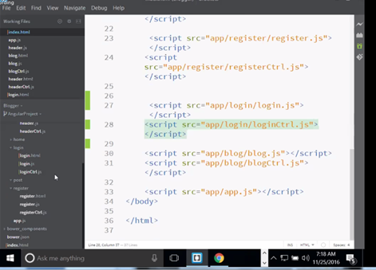

**Step 4: Integrate**

* **Adding in the angular module**

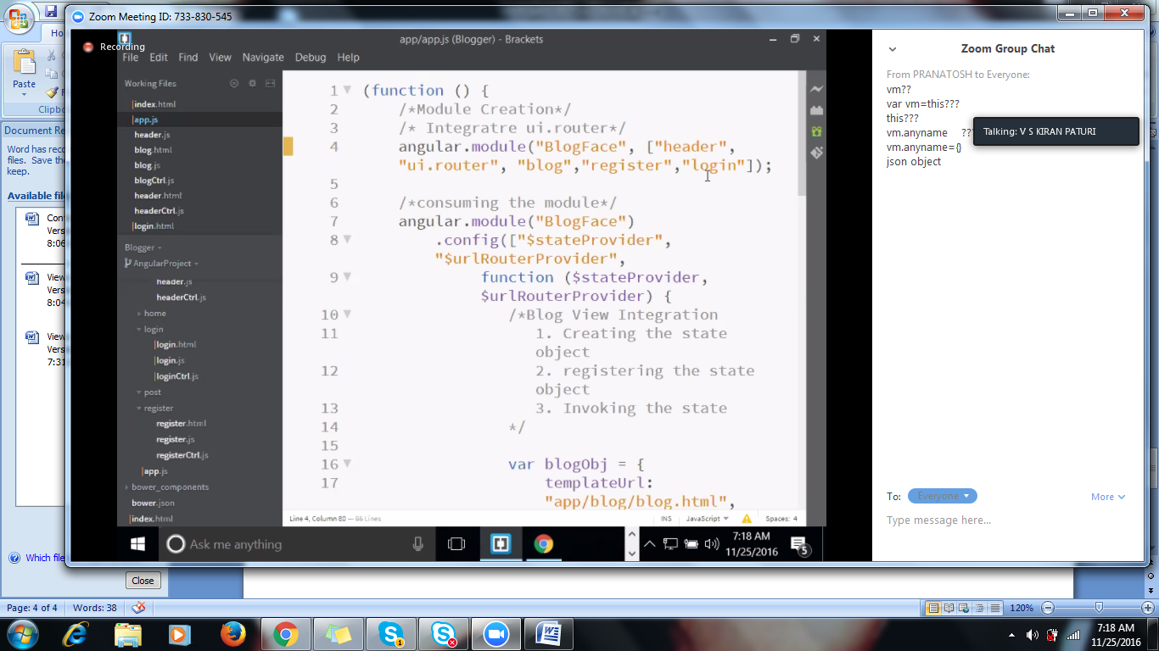

* **Add login Controller to Login Object**

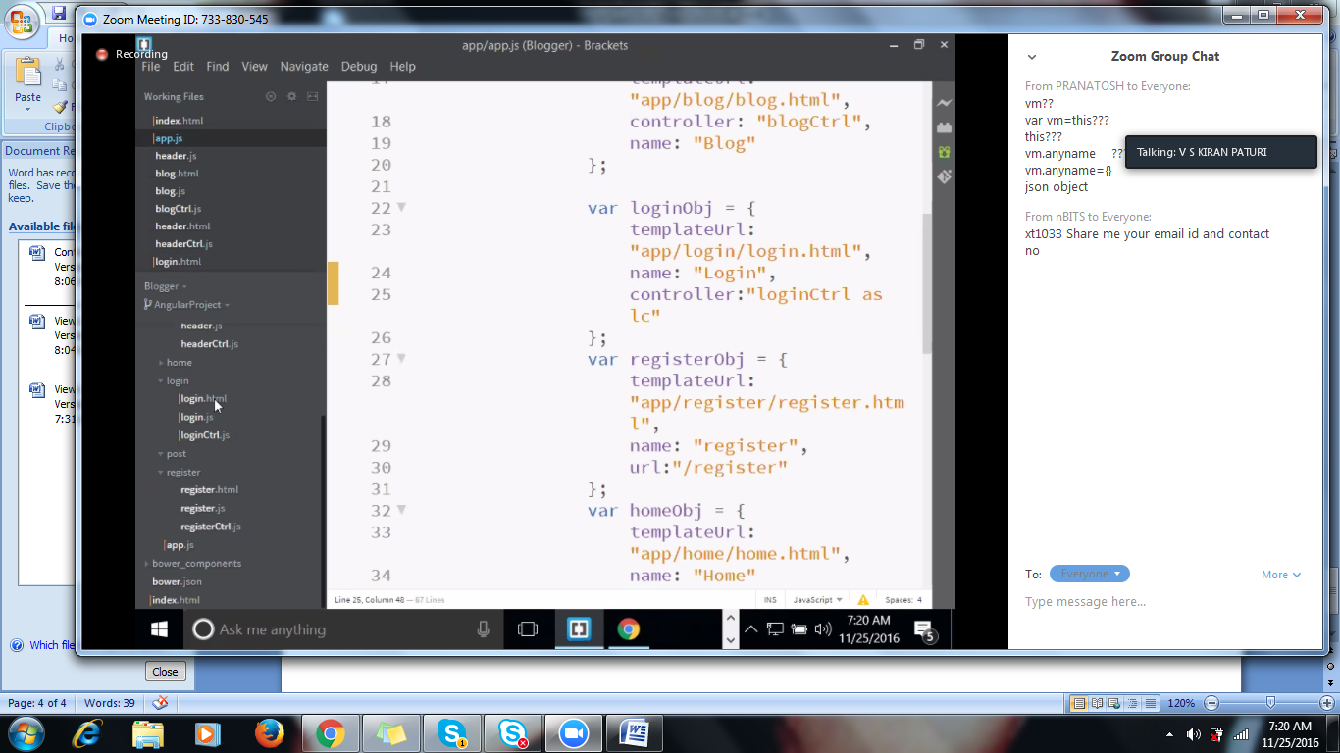

**Login-page**

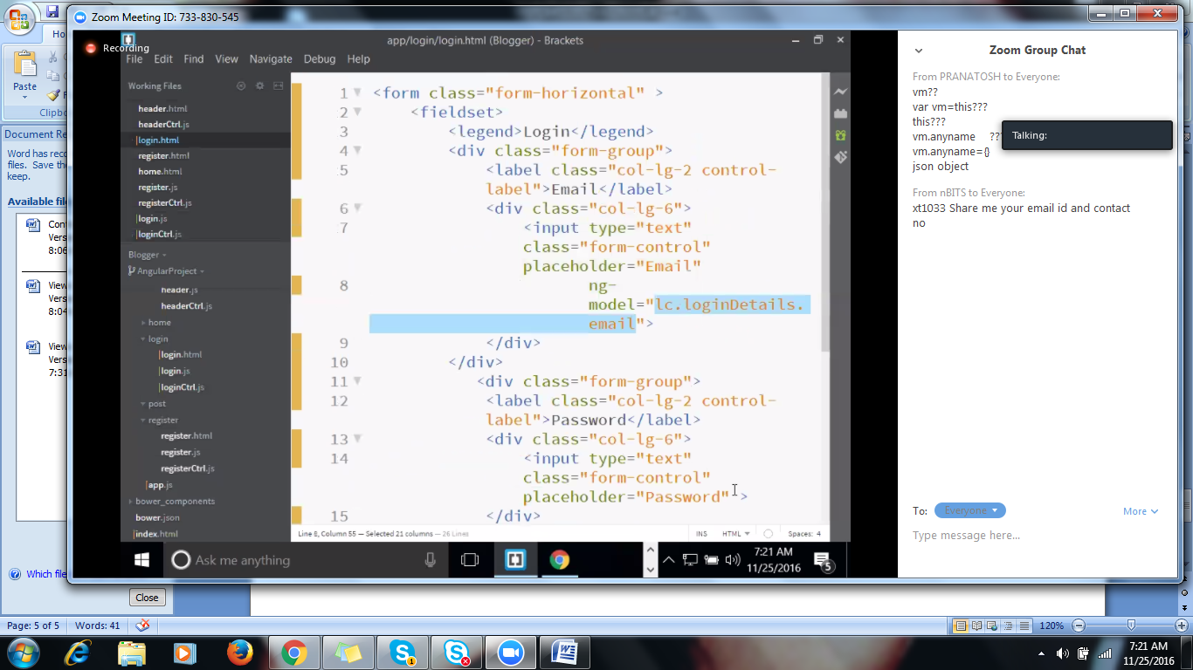

**Similarly For Password**

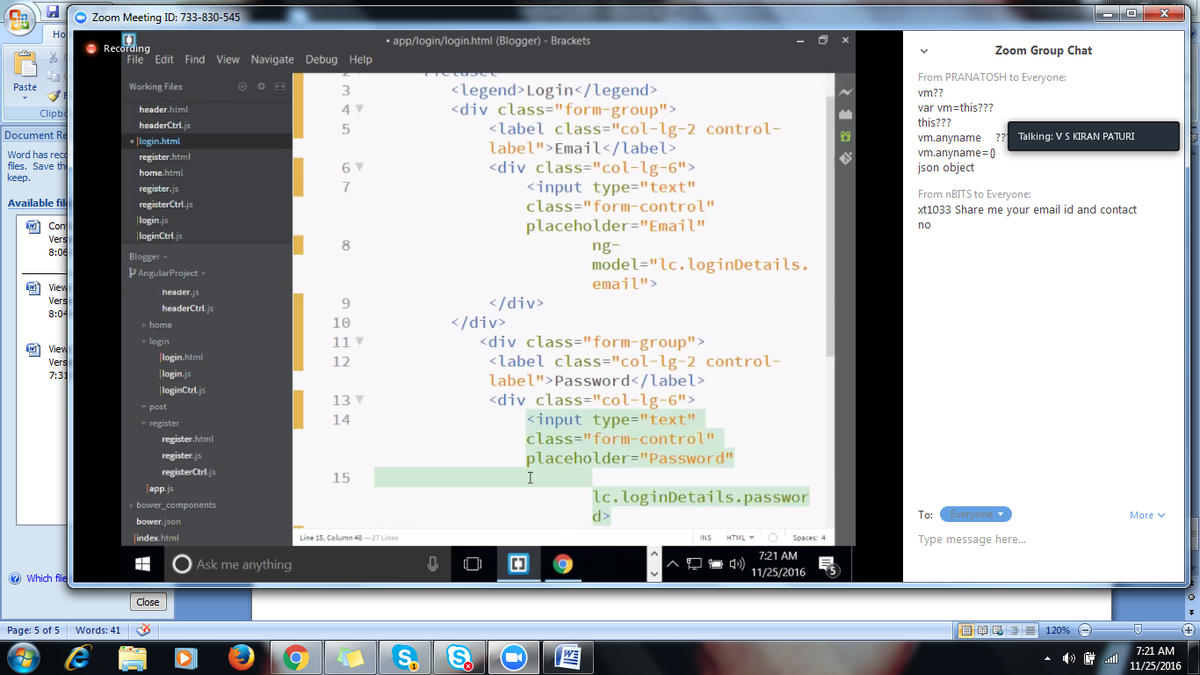

**Button**

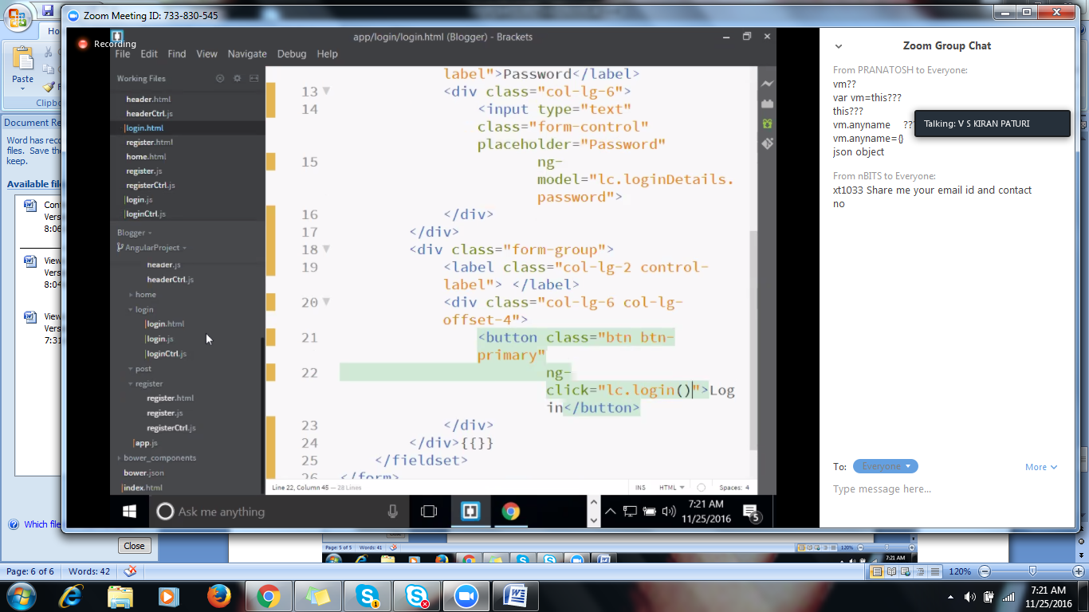

**Adding login button function**

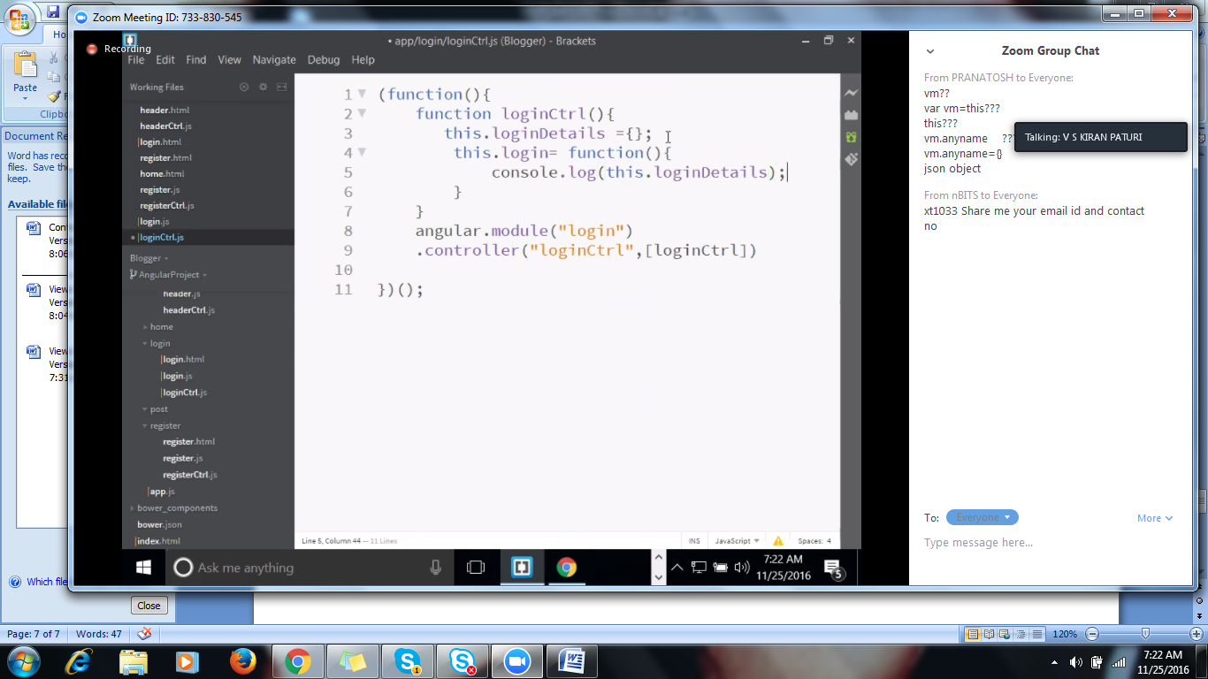

**Enabling validation in Angular js**

**To implement the validations in angular, there are few steps involved,**

**Step1: Form must be having a name**

**Step2: Control which u wants to validate should also have name property**

**Step3: Control must be having the ng-model.**

**Enabling validation**

**There are built-in validators available with the angular.**

**Ng-patterns**

* **ng-required**
* **ng-minlength**
* **ng-maxlength**

**Implementing validation in html page as below**

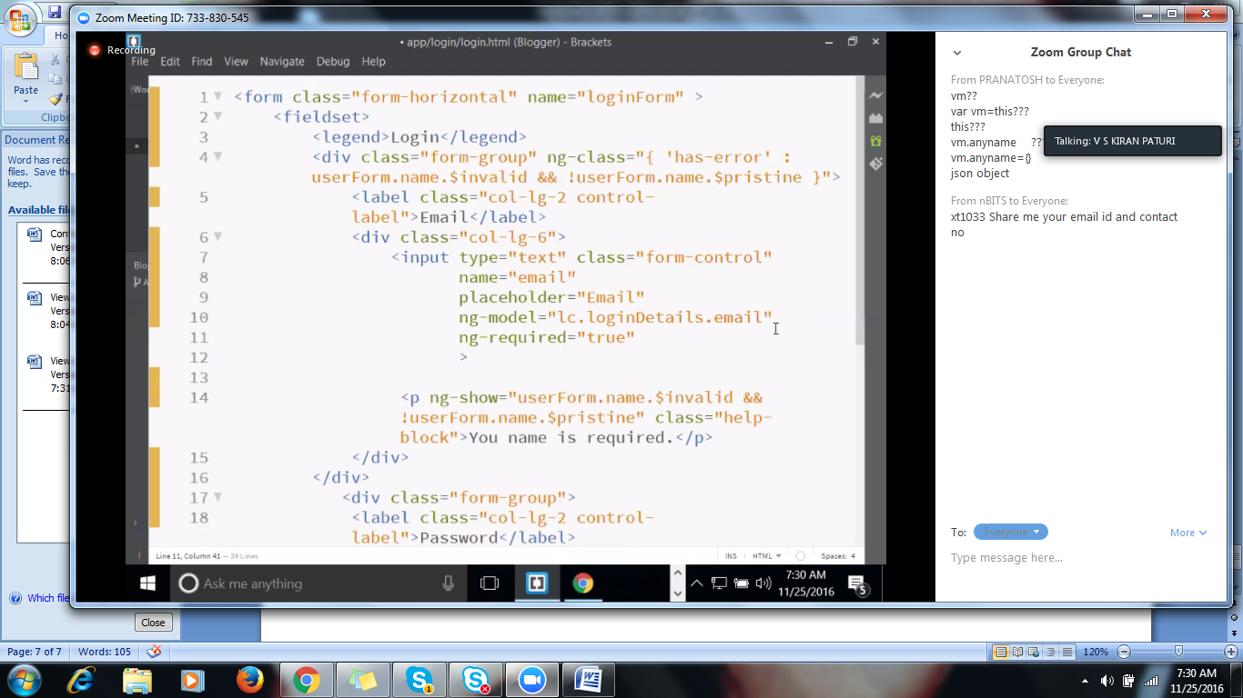

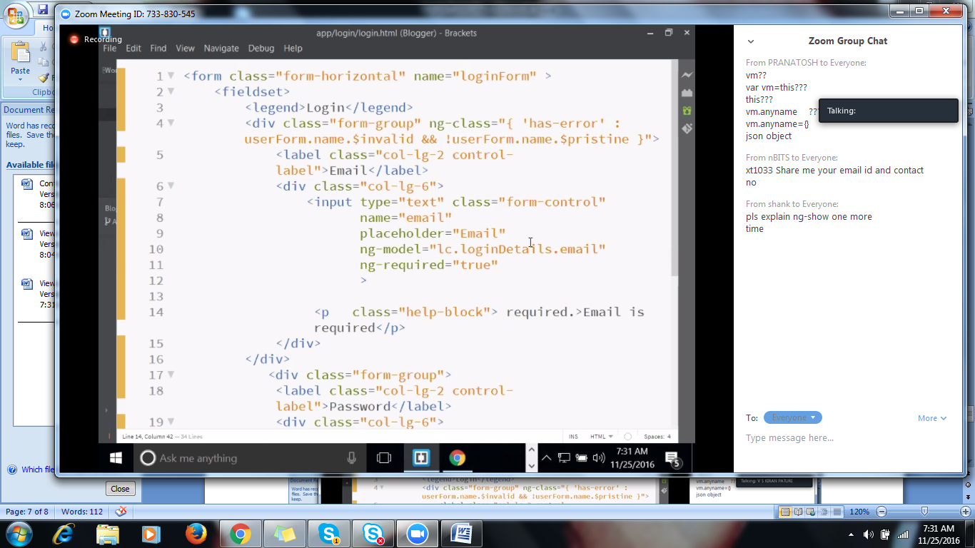

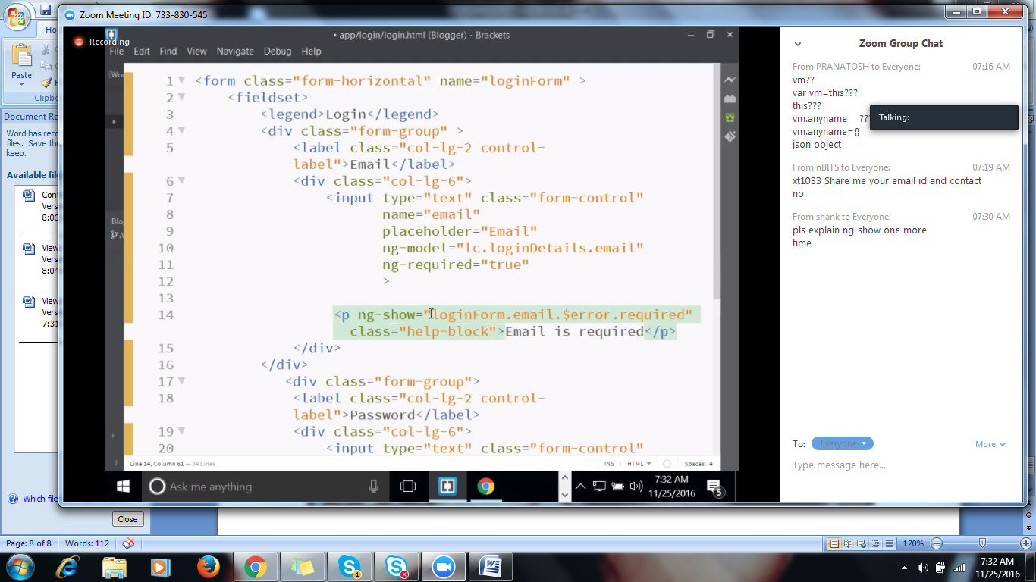

**To show the error in red color**

**Has-error built-in class for bootstrap**

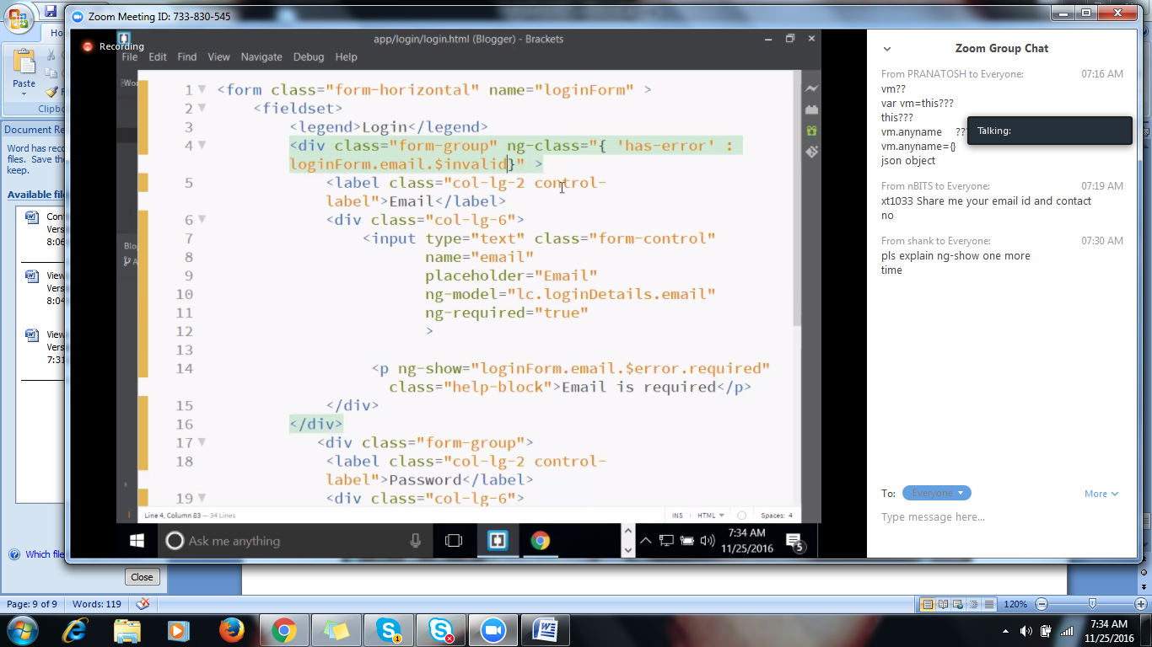



**In the above Snap shot It means that,Error is firing because of required field validation, then throw a message.**

**Adding min-length validation**

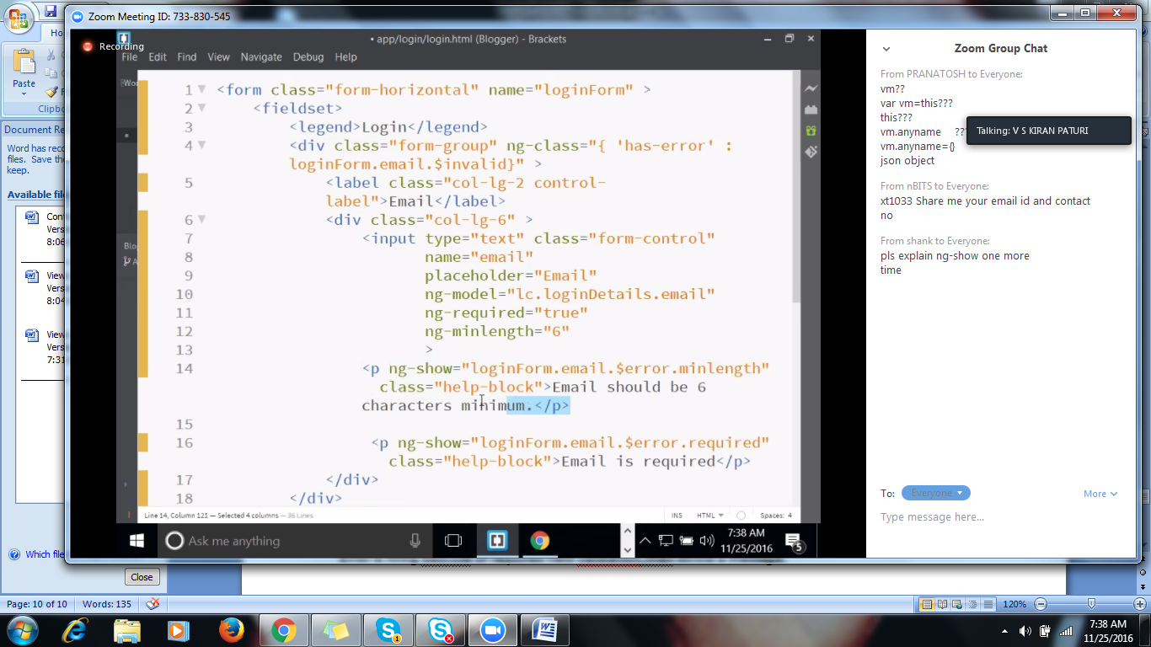

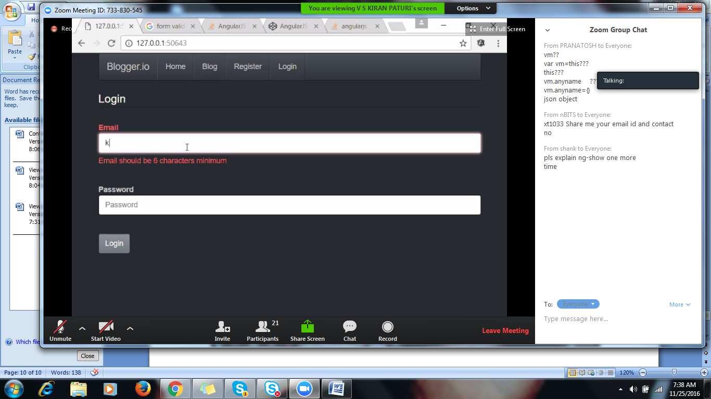

**In the browser**

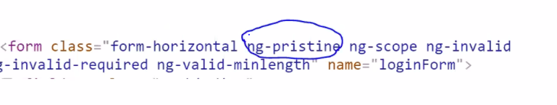

**Control will be in the form of Pristine(if it is fresh i.e., loading form for the first time),Upon editing, will be changed to ng-dirty**

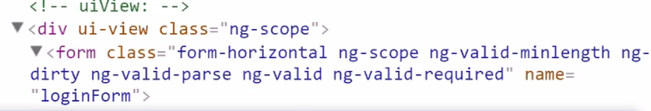

**Only show the message if the page is dirty**

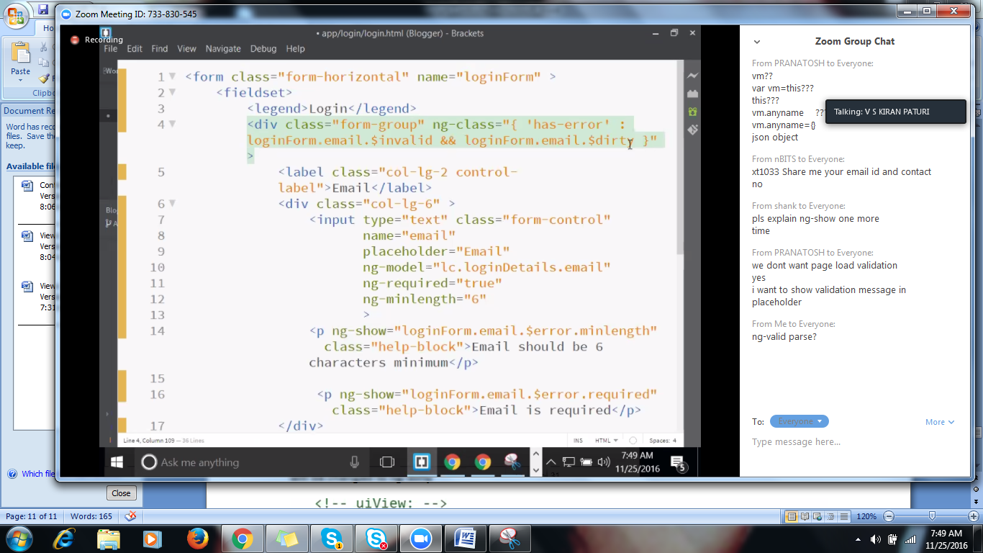

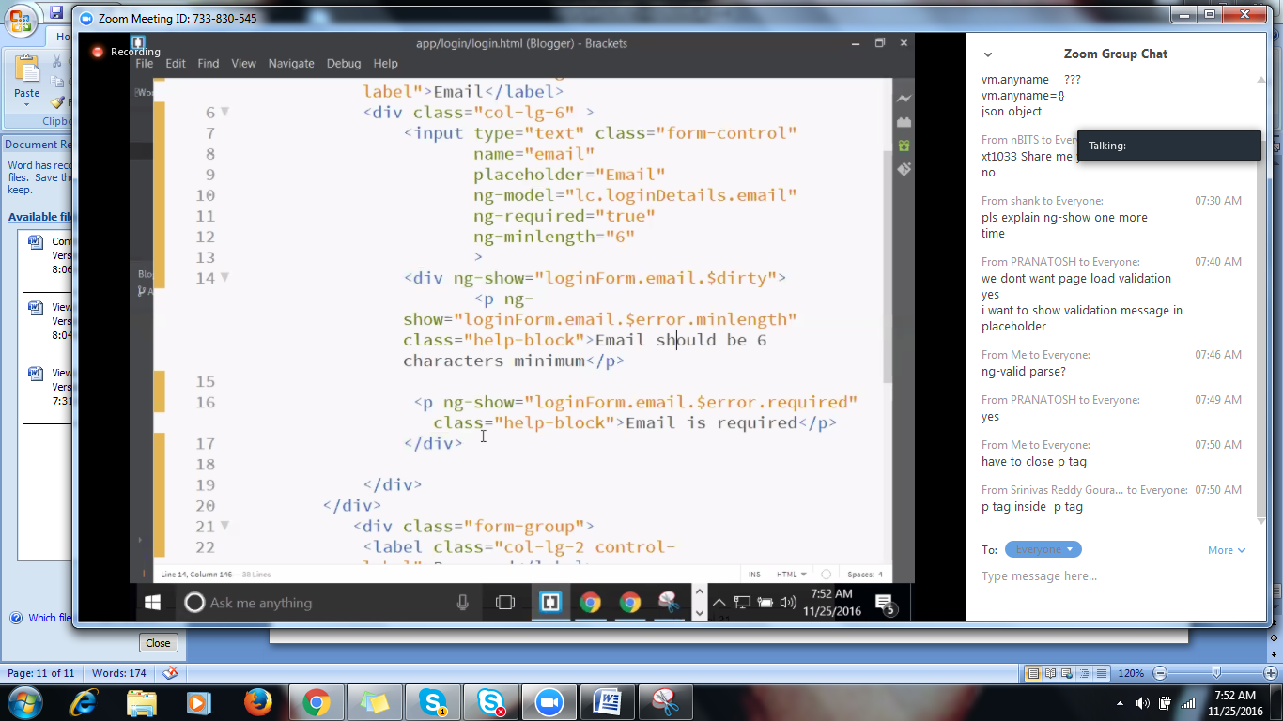

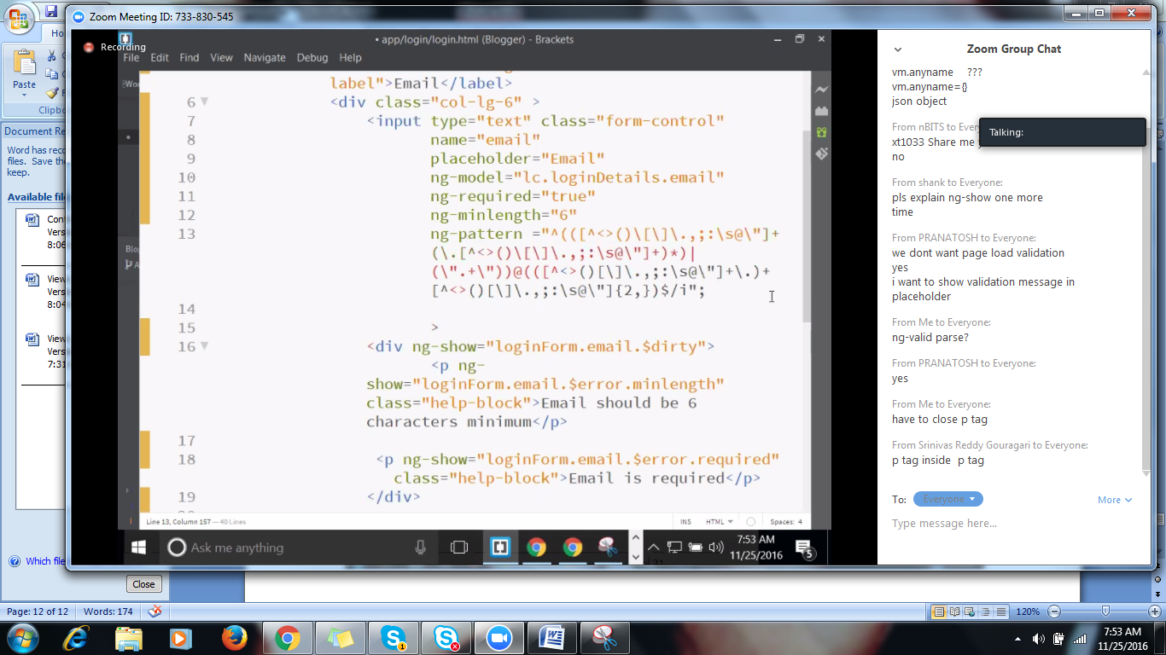

**Adding 3rd validation**

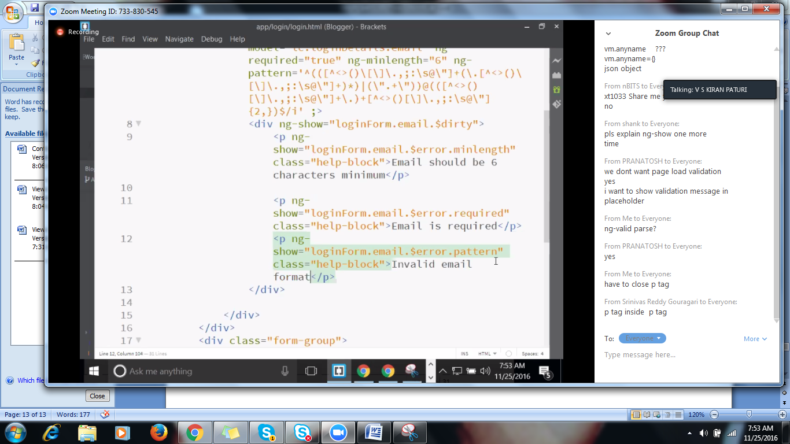

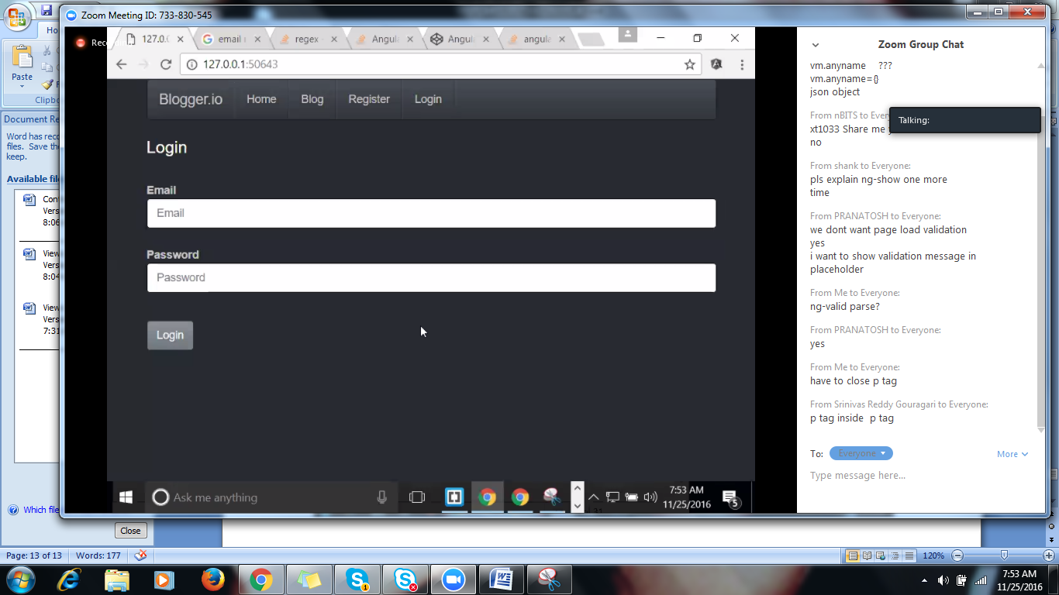

**We can give than g-pattern in cntrl as well**

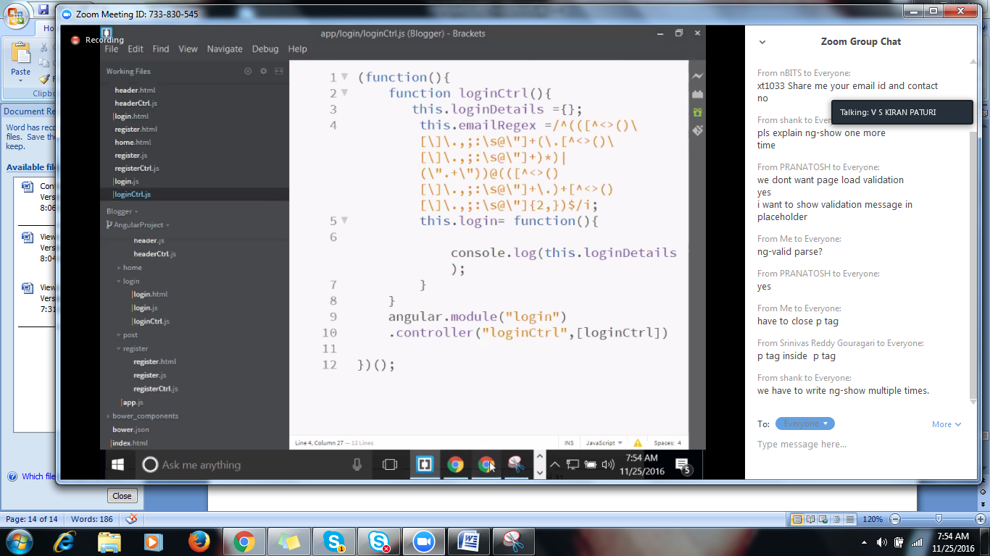

**In the html page,change regex to below shown**

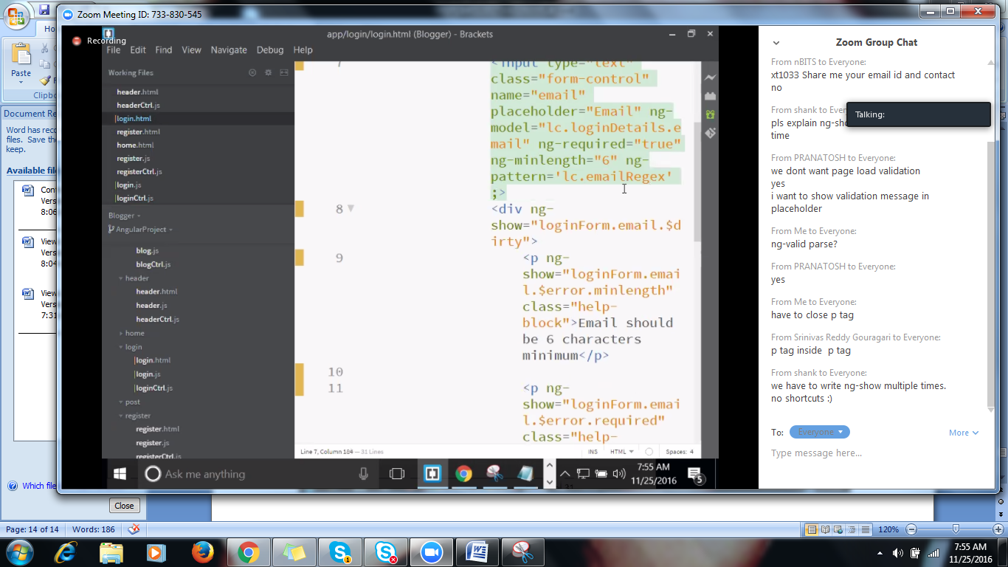

**Changing color of the class**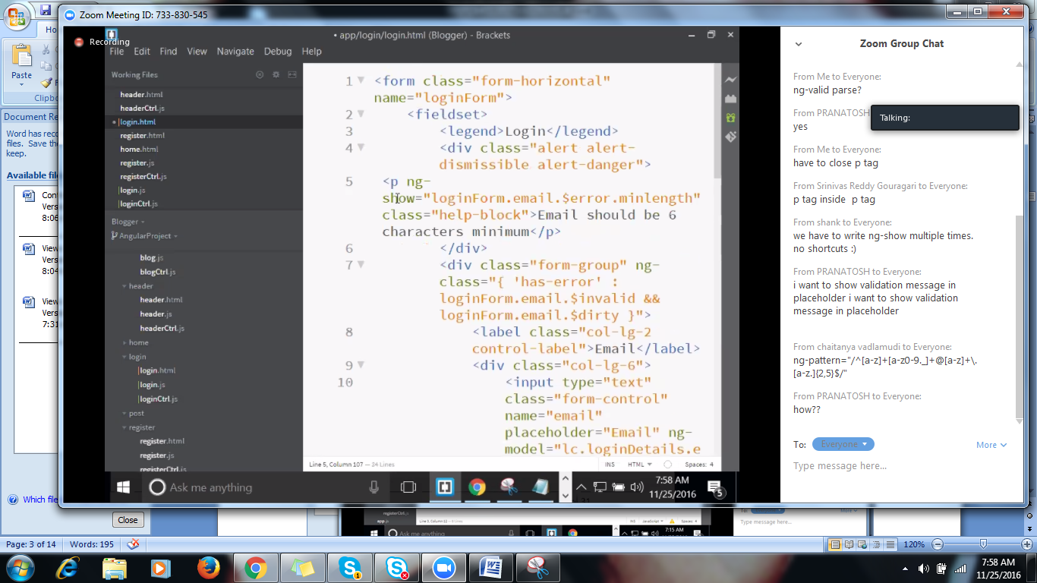

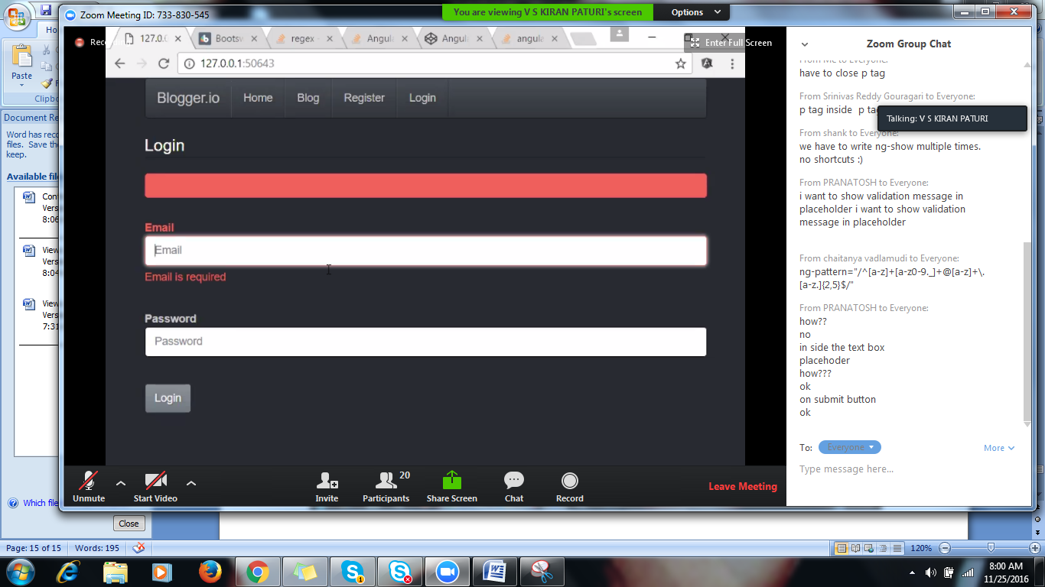

[**https://codepen.io/sevilayha/pen/xFcdI**](https://codepen.io/sevilayha/pen/xFcdI)

**Button is disabled if page is invalid**

